**Cybersecurity Careers & Certifications: Because HR Needs Acronyms**

**Meta:** Wanna get into cybersecurity? Heard about “certs” but don’t know your CISSP from your OSCP? Wondering if you need a PhD in Packet Sniffing? Let’s break it down; careers, certs, and the subtle art of not wasting thousands on alphabet soup.



Photo by [Lewis Keegan](https://unsplash.com/@skillscouter?utm_source=medium&utm_medium=referral) on [Unsplash](https://unsplash.com/?utm_source=medium&utm_medium=referral)

**1. First: Do You *Need* a Certification?**

No.  
But also, yes.  
It is complicated.

Here is the deal:

* **Certs don’t make you skilled.** But they make HR think you are.
* **Some roles require them.** Especially if the government’s involved.
* **They can guide your learning.** Or be glorified flashcards.

Think of certs like gym memberships, having one doesn’t mean you are fit. But they can help, if you actually use them.

**2. Cybersecurity Career Paths (Pick Your Flavor of Stress)**

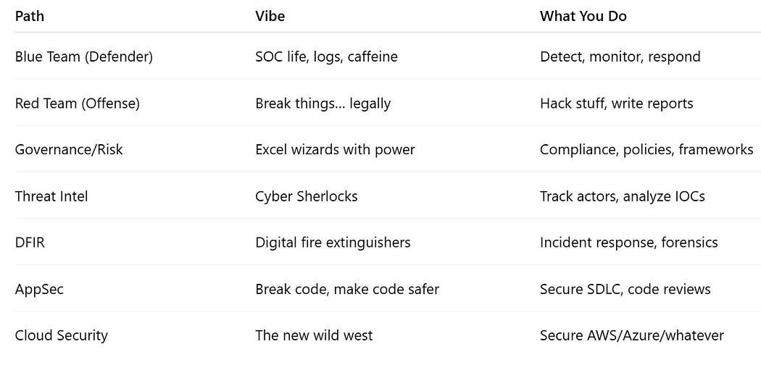

Paths

No matter your path, there’s a cert (and a burnout phase) waiting for you.

**3. Popular Cybersecurity Certifications**

* **Beginner Level**

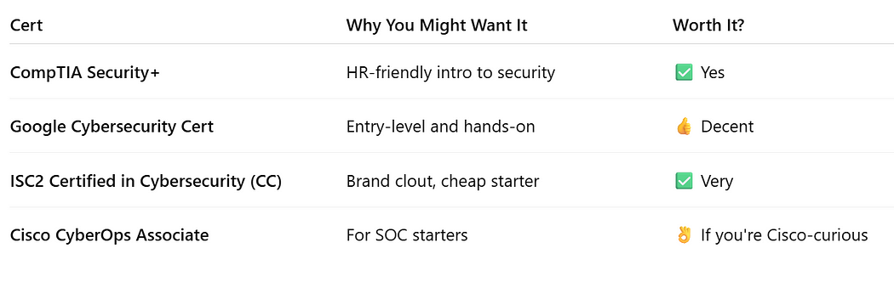

Beginner level

If you are just starting out, don’t spend $1,000. Spend time on labs.

* **Intermediate Level**

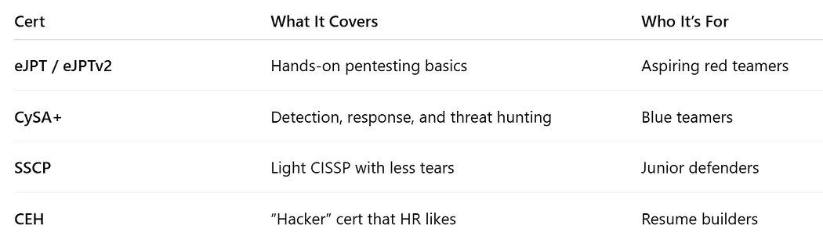

Intermediate level

CEH is like a security-themed quiz night (fun for buzzwords, but not deep).

* **Advanced & Specialized**

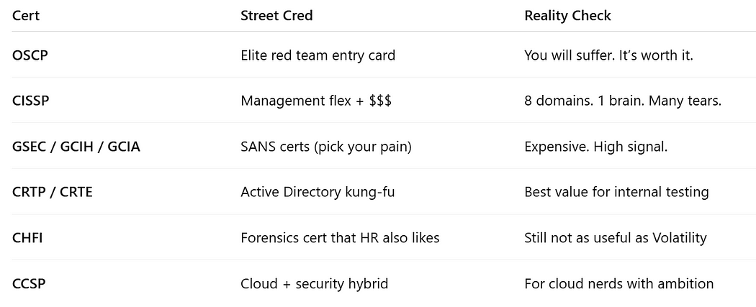

Advanced level

If your goal is hands-on skill, go **OSCP**, **CRTP**, or **PNPT**.  
If you want to be a manager or policy lord, go **CISSP**.

**4. Which Certs Are Actually Worth Your Money?**



Money…Money… Credit: Giphy

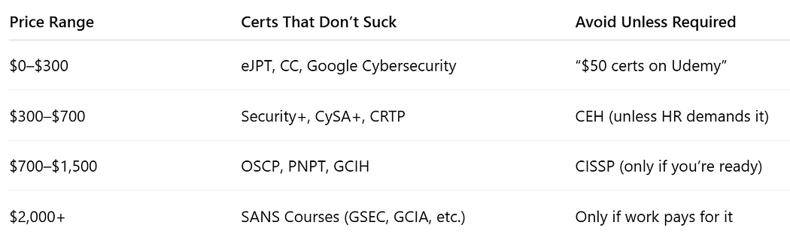

prices

Don’t bankrupt yourself for acronyms. Skill beats certs, unless you’re job hunting.

**5. Certification ≠ Skill**

Here’s what most people forget:

* Passing a cert doesn’t mean you can do the job.
* Many hiring managers care more about your portfolio, lab experience, and problem-solving.
* Having 6 certs won’t save you if you don’t know what a reverse shell is.

Certifications are the seasoning, not the meal. Focus on labs, projects, and public work (like CTFs or GitHub).

**6. How to Actually Build a Cyber Career (Without Losing Your Mind)**

1. **Pick a path** → Defender? Offense? Risk?
2. **Learn fundamentals** → Networking, OS, scripting
3. **Get hands-on** → Labs, CTFs, break stuff legally
4. **Certify smartly** → Not everything needs a badge
5. **Build a portfolio** → Show, don’t tell
6. **Network** → No, not Layer 3. Meet humans. Join Discords, LinkedIn, local meetups.

**Bonus:** Document your learning. Start a blog. Even if no one reads it, you will learn.

**7. Things NOT to Do**



Do not Do That. Credit: Giphy

* Collect 10 certs with zero lab time
* Think Security+ will make you a pentester
* Skip fundamentals for “elite red team” certs
* Assume a CISSP means you’re good at cybersecurity
* Pay $6,000 for a bootcamp that teaches you copy-paste Metasploit

**8. Career Roles + Recommended Certs**

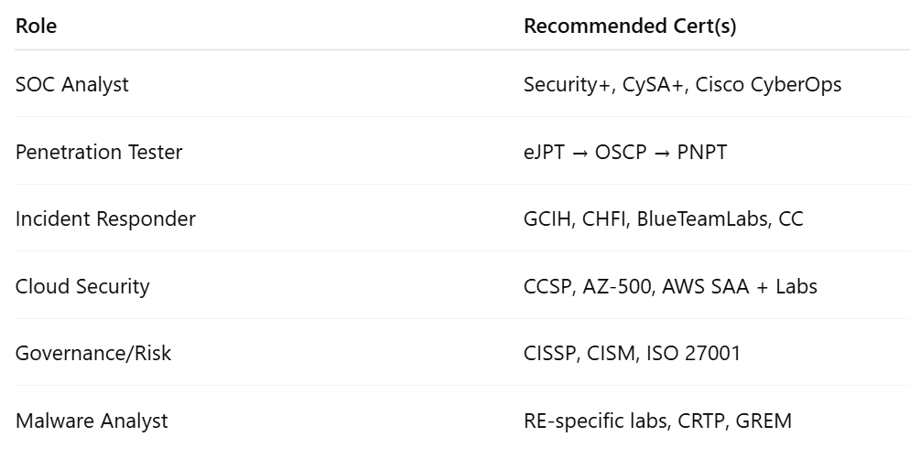

Roles and Recommended Certifications

Don’t chase the cert. Chase the skills the cert is trying to prove.

**TLDR**

Cybersecurity careers are diverse. Certifications help but won’t carry you.  
Pick a direction. Learn the basics. Lab it out. Certify if needed. Don’t blindly follow YouTube influencers with “TOP 10 CERTS FOR 2025” in their titles.

Certs get you interviews. Skills get you hired.

**Enjoyed the read?**  
Smash the follow button, drop a comment, and share this with someone who still thinks “password” is a good password.

If you enjoyed the reading, kindly subscribe to my page: [Here](https://medium.com/@Ethical_DarKVoicE/subscribe)

More chaos, hacks, and knowledge coming soon. Stay safe, stay paranoid.